Chapter 16, Problem 59.

Find v_{o}(t) in the circuit in Fig. 16.82 if v_{x}(0) = 2 V and i(0) = 1 A.

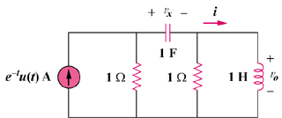

Figure 16.82
For Prob. 16.59.

